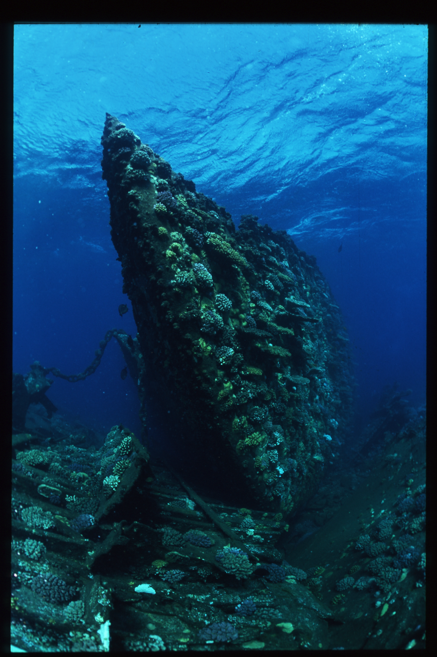
THE TILE WRECK~
her true story
PETER COLLINGS

FREE E –BOOK EDITION

